Cisco Duo Enrollment (MFA or Multifactor)
*Please read all instructions. There are additional instructions at the bottom*
- Staff will receive an enrollment email from Duo Security that looks like the one below. Please have a cell phone ready before Duo enrollment begins.

Click on the link to begin enrollment; it will open a new webpage.
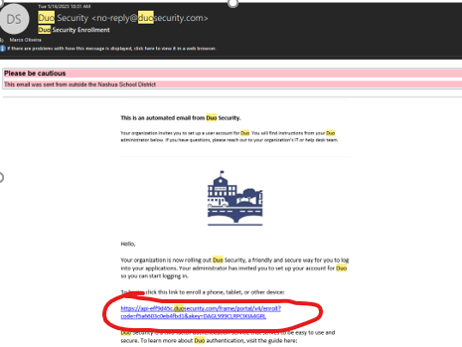

- If your browser is not updated, you may see the following image; click “Skip for now” to proceed.
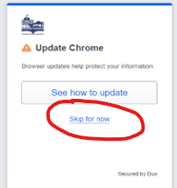

- The Welcome page appears. Click Next.
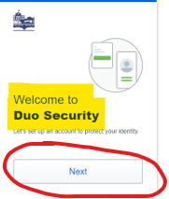
- Click Next until the page below appears.

- Click on the option available (Duo Mobile).
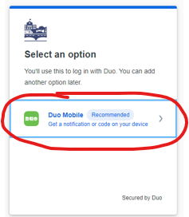
- There will be a prompt to enter a phone number. Please use the same cell number as the phone to download the Duo application (next step). Enter the cell number and confirm it is correct.

- The prompt to download the Duo app will appear. Navigate to the App Store (iPhone) or Google Play Store (Android) and download the Duo mobile app. Duo will have a green icon.
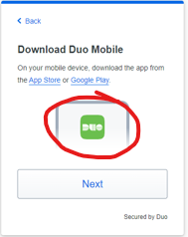

- Open the Duo mobile app and click continue and then QR code:
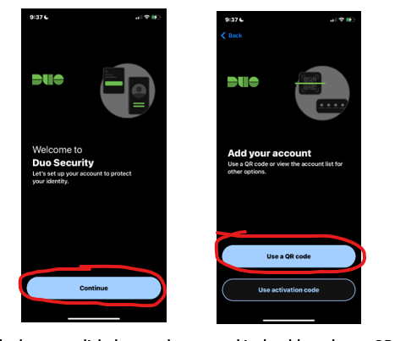
- Go back to the computer and Click the Next button in the browser, and a QR code will appear, which will scan on the Duo Mobile App. (Do not use the phone camera app; this will not work.) You have completed Enrollment in Cisco Duo!

- Moving forward, when logging into a Duo-protected application (email, X2 Aspen), the following prompt will appear when entering your email and password:
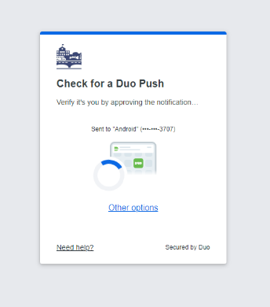

- The registered cell phone will get a notification from the Duo App. Open the app and click on the green approve button. (If you receive a Duo Push notification and are not attempting to log in, please hit deny and contact IT immediately.) Once approved, all applications will be accessible.
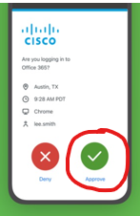
The Prompt will look similar to this image but contain a different image in the top left corner.

- If you have forgotten your phone at home, please contact the IT department through the help desk(or phone if you cannot submit a helpdesk) and let them know, and they will be able to assist you in bypassing Multifactor that day. They will walk you through the steps to get into your accounts.

* If you do not have a passcode or Fingerprint login on your phone, you may receive a message stating you need to set up a lock method to proceed.
For the time being, this is required. If you have any additional questions, please see the Duo MFA section on the Nashua.edu website homepage.

